Dated: 2023-04-20
To
Anders Snell
Anders.snell@aforsk.com

Subject: Submission of Final progress report of research project (grant application ref. no. 21-106) and request for release of remaining 119 601 kr of research grant

The project leader on the behalf of Linnaeus University is highly grateful to Åforsk stiftelsen for providing the financial support for the project 21-106. In the attachment, please find the final progress report of the research project (ID 21-106).

The first progress report of the Project 21-106 was submitted on 15th Dec, 2022. The project leader requested on 16th Dec, 2022 for extending the project deadline till 30 April, 2023, which was approved by Åforsk on 19th Dec, 2022.

This final progress report of the project has two Annextures. The Annex-I is the draft article that is intended to be submitted to a suitable journal and Annex-II is the financial summary of the project. Along with the submission of this report, it is requested to kindly release the remaining 119 601 kr of research grant in favor of Linnaeus University at the earliest possible.
Thank you.

M. Asim Ibrahim
Principal Investigator
Researcher, Linnaeus University, Sweden

Final Progress Report

Early detection of deep-seated waste and biofuel fires through innovation

(Project 21-106)

20th April 2023
Muhammad Asim Ibrahim
Department of Biology and Environmental Science, Linnaeus University
www.lnu.se


Project Overview

The title of the project 21-106 is the “Early detection of deep-seated waste and biofuel fires through innovation”. In this project geological technique (electrical resistivity tomography) is intended to use for early detection of deep-seated fires in waste and biofuel storages. The first installment of the project funding amounting 500k SEK was received to Linnaeus University on 23rd Dec, 2021. After receiving the funding, a project home page was established on the website of the Linnaeus University (https://lnu.se/forskning/sok-forskning/forskningsprojekt/projekt-tidig-upptackt-av-djupt-sittande-avfall-och-biobranslebrander-genom-innovation/) and project was formally initiated.

The activities conducted in this project can broadly be classified into two sub-categories, first is the development of experimental technique through series of small-scale experiments and second is the networking activities. The purpose of networking activities is to involve suitable and relevant actors/companies/institutes in the project that can contribute to the project with their knowledge and experience regarding additional techniques for early detection of waste fire, besides that of geological methods, so that a comparative study of geological methods with the conventional techniques (e.g. gas/smoke detectors, IR cameras etc.) for early detection of smoldering fires could be made and results could be communicated with the relevant actors both nationally as well as internationally. The networking activities are intended to write articles with researchers around the globe within the domain of large outdoor fires and how these risks could be minimized.

The details of institutes/organizations and researchers that are currently involved in the experimental part of the project is as follows:
Technical Team:
- Asim Ibrahim (Project leader, Linnaeus University, Sweden)
- Torleif Dahlin (Lund University, Sweden)
- Simon Rejkjær (Lund University, Sweden)
- Nabeel Afzal Butt (Lund University, Sweden)
- Dan Madsen (Lund University, Sweden)
- Konard Wilkens (Lund University, Sweden)
- Håkan Frantzich (Lund University, Sweden)
Support Team:
- Thomas Günther (LIAG - Leibniz Institute of Applied Geophysics, Germany)
- Mattias Eggert (Unifire, Sweden)
- Björne Sandström (Unifire, Sweden)
- Magnus Ingelsten (Winguard, Sweden)

Development of experimental strategy
In the project a sequence of experiments was performed to lead the way towards development of experimental strategy and to understand the effect of different parameters on the detectability of smoldering hotspots using the technique of electrical resistivity tomography (ERT). The ERT is a powerful, non-invasive geophysical technique with several application areas e.g. to determine the thickness of layers of different material under the surface, to detect buried faults, mapping of ground water and landfill boundaries etc. However, this project is the first attempt to use ERT for early detection of deep-seated fires. In this technique, electrical resistivity measurements are made at the surface with the help of combination of four electrodes at a time, where two electrodes are used for passing the current and rest of the two for measuring resistance. Data of resistance is collected using several combinations of electrodes and later date of resistance is converted to resistivity to develop the contour plots.

In this project, firstly, there was a risk that conductivity data may suffer from bias due to heterogeneity of test material. Secondly, there was a need to determine the degree of free moisture, bounded moisture, and compactness of material to be maintained in the test material to ensure the uninterrupted flow of electric pulses for detecting the smoldering hotspots. The challenge of heterogeneity of material was solved by using a uniformly sized wood pellets and later saw-dust was used as the additional test material.

2.1 Experimental Setup
Fig. 1 is a snapshot of the experimental arrangement. In these experiments, a 162 mm deep, variable diameter plastic bucket (diameter top = 162 mm, diameter bottom = 154 mm) was employed for holding the test material. Metallic screws were inserted in the wall of the bucket in a way that four rings of conductors (8 contact points/ring) were attached to the wall of the bucket. From brim to the bottom of the bucket, the diameters of the bucket at the position of first, second, third and fourth electrode rings are 16.3cm, 16cm, 15.7cm and 15.4cm, respectively. The metallic screws/conductors’ positions are separated apart by 5 cm in the vertical direction and horizontal separation distance between screws is 6.40 cm in the first ring (close to brim), 6.28 cm in the second ring, 6.16 cm in the third ring and 6.04 cm in the fourth ring (close to bottom). The average horizontal distance between metallic screws is 6.22 cm. To simulate smoldering fire, an externally powered hot resistant wire was rolled over a wooden cuboid and then placed approximately 10 cm below the top ring (i.e. approximately the position of the third ring of conductors from the top). The characteristic length of smoldering fires is about (≈ 7.5 cm) i.e., half of the diameter of the bucket (15.7/2) at that position element (see Fig. 1a).

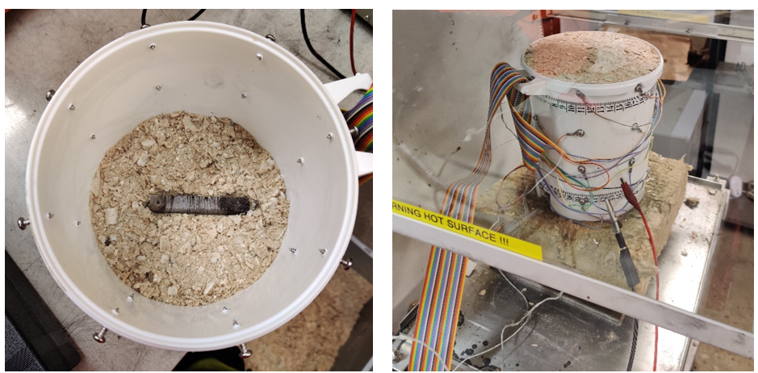
Figure 1. Snapshot of experimental setup: (a). hotwire arrangement in the test material and top view of test bucket and (b). side view of the test bucket
After attaining the conditions suitable for the flow of electric signal through the test material, each experiment was conducted for the duration of about 400 minutes (6.6 hrs). The data of conductance was recorded after every 20 minutes for every quadrupole configuration at each conductor ring. Each recorded value represents the average conduction through the combination of 4 electrodes. Some measurements were also taken diagonally i.e. using the electrodes that are positioned at different electrode rings. The data of conductance was inverted to get resistivity values and plotted against 20-time-intervals at which data was collected. A comparison of rate of change of resistances at 4 cross-sections was made. To properly interpret these resistivity values, physical observation of the test material was also made at the end of the experiment. After the completion of the experimental run, test material was taken out from the test bucket and pictures were taken intermittently to see the travel distance of smoldering front and to record the final size of the smoldering hotspot.

Experiments
To determine the minimum threshold values of free moisture in the test material, which is essential for performing the resistivity tomography, a series of raw tests were performed. Firstly, 8 mm wood pellets were employed as the test material and before running any experiment, test material was first placed in the climate chamber for period of 24 hrs. In the climate chamber, the test material was exposed to the environment with 50% and 100% air humidity, in respective experiments. Due to hydroscopic characteristics, the test material (wood pellets) takes up moisture from the air and this acts as the bounded moisture. This set of experiments were dedicated to determining the degree of bounded moisture that is necessary for conducting the electric signal through the test material. A major conclusion of this series of raw experiments is that the detectability of smoldering fires is indifferent of air humidity to which material is initially exposed or in other words is independent of bounded moisture in the test material. In the experiments, pre-exposure of test material to an environment of 100% air humidity did not support the flow of electric signal through the test material. Secondly, grain size of material to be tested is found to be an important factor that affects the contact resistance between material and the electrodes. Based on the results of first series of experiments, it is decided to explore the effect of free moisture on degree of detectability of hotspots and also to run the experiments with greater degree of compactness in the test material so as to have the better contact of electrodes with the material.

In order to achieve these conditions, saw-dust with 25% and 50% moisture by weight was used as the test material in the second series of experiments (phase-II). Here it was intended to see the effect of free moisture on detectability of smoldering hotspots. The test results shows that electric signal conducts very well through the test material while having 50% free moisture contents or higher. These findings are of practical importance as most of the freshly cut biomass has moisture contents up to 60% by weight. Similarly, waste fuels that are stored under open sky in the form of large piles can have very high moisture contents after precipitation. Free moisture, in the piles of waste and biofuels activates the microbial processes, which leads to the development of smoldering hotspots inside the stored material.
Based on the results of phase-II of experiments, a new set of experiments were designed (phase-III), where it was planned to simultaneously do the resistivity- and temperature profiling of the test material under the influence of externally controlled smoldering fire. For temeprature profiling of the test material, three thermoucouple trees (five thermocouples per tree), were positioned in the test bucket at the elevation of 30 mm, 75 mm, and 125 mm from the base of the bucket. Thermocouples were connected to the dataloger and values of temperature were recorded with an interval of 5 sec. The conductors for resistivity profiling were positioned as per design of phase-II of experiments. The results obtained are quite promising and it is concluded that geological methods can work very well for detection of smoldering fires under the condition when free moisture contents are high in the test material.

Results
Figures 2–5 shows the resistivity values for the transmitted current that is measured with each 4 electrode combinations (Two for passing current and two for measuring resistance). Each figure in figures 2-5 corresponds to each electrode ring. The x-axis on the Fig. 2-5 is the measurement number (20 measurements in total, each measurement taken after 20 minutes) and y-axis shows resistivity.
All the graphs in Fig. 2-5 show a sharp drop in resistance in the beginning of experiment. This drop in resistance is attributed to increase in temperature of the test material caused by heat released from the hot resistant wire. When the temperature becomes stable the resistance seems to become stable too, but over time resistance slowly start rising again for a lot of the configurations. It is hypothesized that this increase in resistance attributed to the loss of moisture (caused by evaporation) at the smoldering zone. Due to buoyance moisture shifts from the hot smoldering zone and recondenses again in the region next to smoldering front and this process of sequential evaporation and condensation continues as smoldering hotspots travels through the stored material. Similar results were obtained from 3D resistivity tomography model that was developed in pyGIMLi software (see Fig. 6). Fig. 6 shows that the resistivity first decreased in the zone around the heat source (Figure 6B vs. Figure 6A), which is related to the initial rise in temperature of the test material and then increases again due to drop in moisture contents (Figure 6C vs. Figure 6B).

Physical observation of test material after the end of experiments also confirms that the sub-surface smoldering hotspot travelled in the upward direction (see Fig 7)). Therefore, it is concluded that the drop in resistance caused by rising temperature (i.e. due to imbalance between rate of heat loss from the surface and rate of heat generation inside the stored material) is completely offset by the increase in resistance due to drop of moisture contents at the smoldering hotspot. The support of this argument is that a late rise in resistivity is more prominent at the electrode rings that are located at the smoldering hotspot (Fig. 4-5). The error bars in Fig. 2-5 shows the 95% CI for resistivity values and it is observed that error is relatively large in Fig. 2, which corresponds to the top electrode ring (i.e. located close to the brim of the test bucket). The errors are large in Fig. 2 because the electrodes at this electrode ring do not have as good contact as for the others. Keeping in mind these sources of error, it was ensured in phase-III of experiments that top ring of electrodes have good contact with the test material and for this test material was filled up to a height of 5cm above the top electrode ring. The results of phase-III of experiments are presented in Fig. 8, which shows resistivity sharply increases soon after the development of smoldering hotspot inside the material. These results lead to the conclusion that geological methods have good potential for early detection of smoldering hotspots.

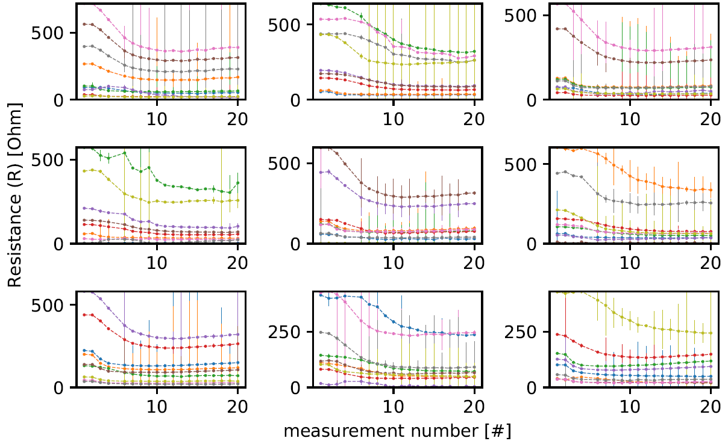
Figure 2. Resistivity versus measurement number for every quadrupole configuration at the first ring of conductors (close the brim of the bucket) (error bars shows 95% Confidence Interval)
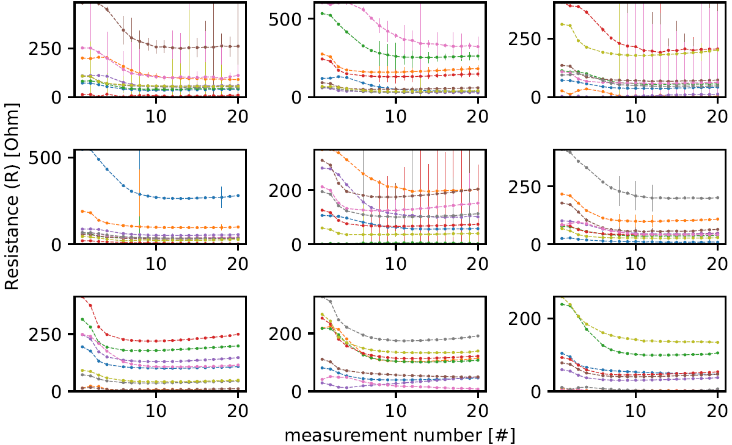
Figure 3. Resistivity versus measurement number for every quadrupole configuration at the second ring (from top) of conductors (error bars shows 95% Confidence Interval)

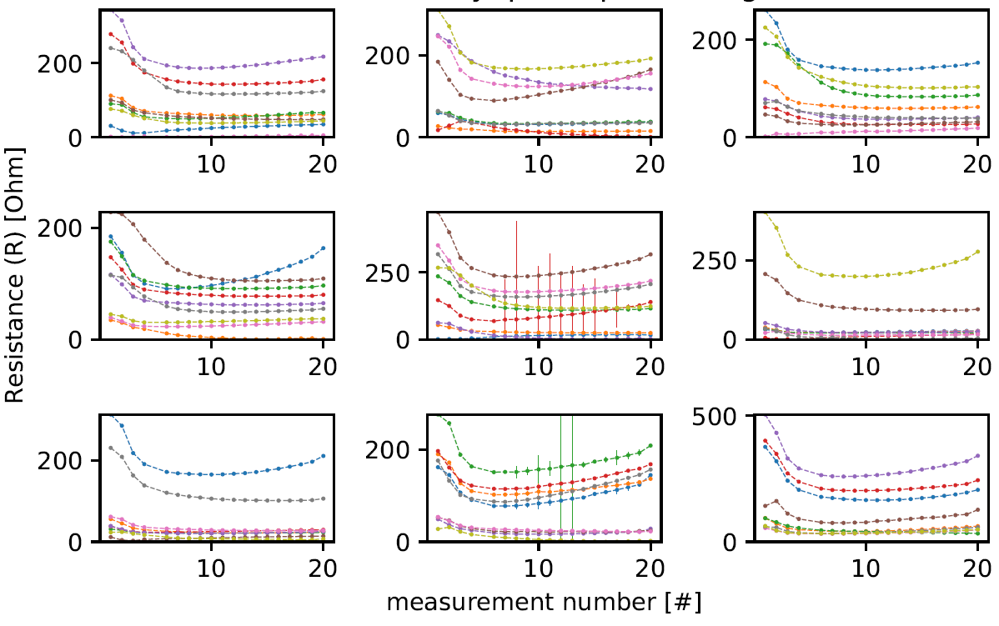
Figure 4. Resistivity versus measurement number for every quadrupole configuration at the third ring (from top) of conductors (error bars shows 95% Confidence Interval)

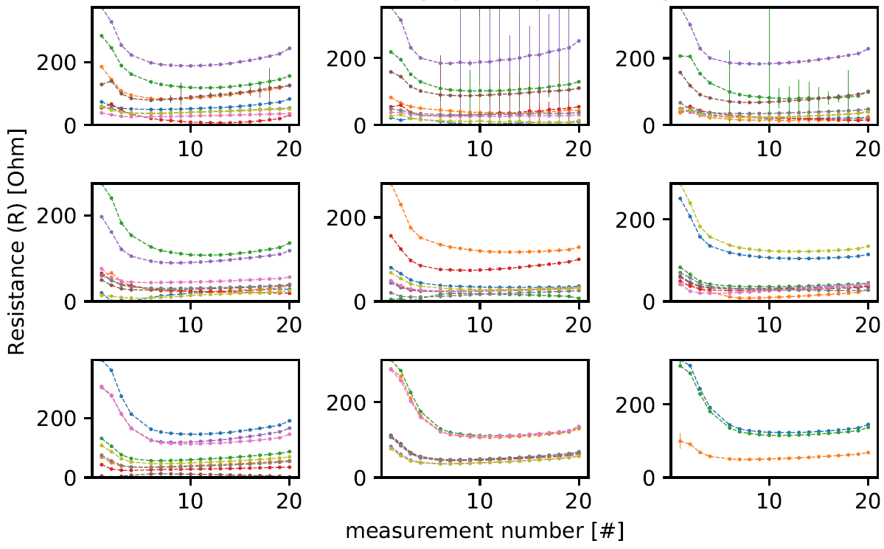
Figure 5. Resistivity versus measurement number for every quadrupole configuration at the forth ring (from top) of conductors (close the base of the bucket) (error bars shows 95% Confidence Interval)
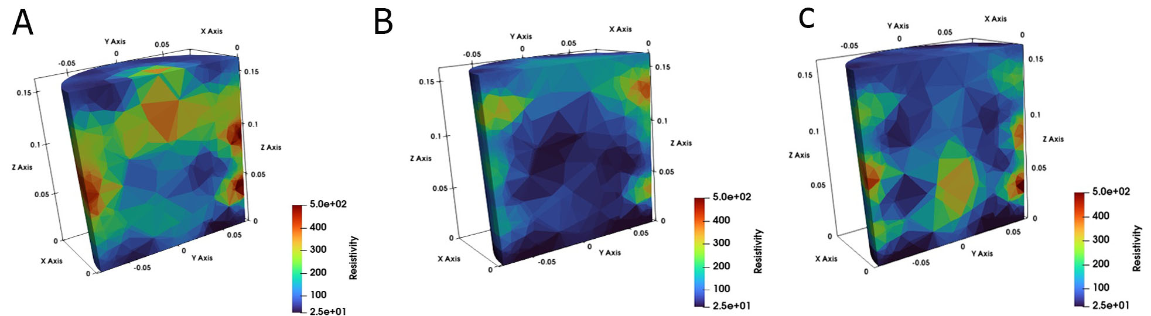
Figure 6. Vertical cut through view of the 3D resistivity model at three different timesteps; a) at time zero, b) after 100 minutes, c) after 380 minutes (Phase-II experiment).

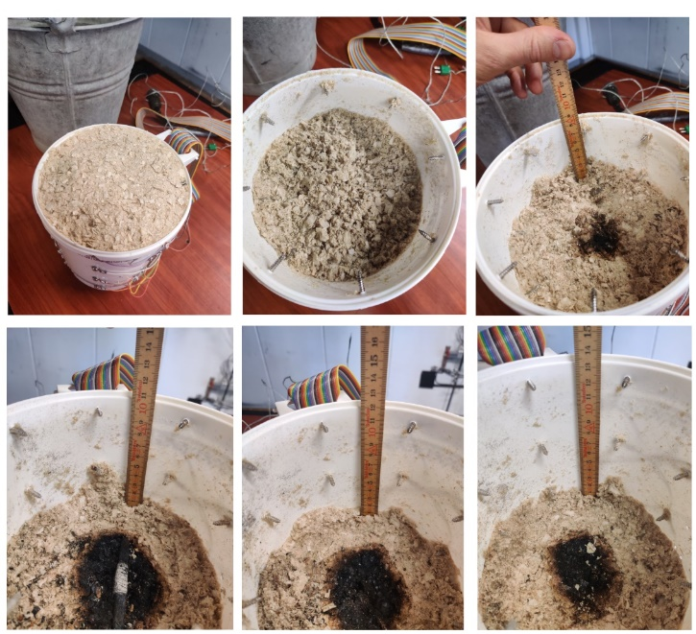
Figure 7. Snapshots of test material and smoldering hotspots at various depths in the test bucket
Figure 8. Ratio plots (a). 3D ratio plot for experiment-5; (b). 3D ratio plot for experiment-6; (c). Resistivity contour plot for experiment-5; (d). Resistivity contour plot for experiment-6
The results of the project are presented in three international conferences: a) GELMON, Sixth International Workshop on Geoelectrical Monitoring” 22-23rd Nov, 2022 (https://www.geologie.ac.at/ueber-uns/tagungen/gelmon), b) Linnaeus-ECO-TECH, 21-23rd Nov, 2022 (https://lnu.se/mot-linneuniversitetet/aktuellt/kalender/2022/konferenser/linnaeus-eco-tech-2022/), and c) Prevention and Mitigation of Waste Fires conference-3 (Georgia) 15th March, 2023. It is further intended to publish a peer reviewed journal article (a draft copy of article is attached in Annex-1).

Future view
This study gave very useful practical knowledge on the use of ERT, but several questions still need to be addressed before being able to use this state-of-the-art-technology at practical scale for early detection of smouldering fires. For example, there is need to develop characterization charts of resistivity corresponding to hotspots that are produced in different storage conditions and for different materials. More research is also needed to study the operability and detection limit of ERT, and how it could be employed in real life scenarios.

